Energy Efficiency Conservation Strategy

Town of Leesburg, VA

The Town of Leesburg’s **Energy Efficiency Conservation Strategy (EECS)** was developed in early 2024 as part of the Town’s application for federal funding via the Energy Efficiency Conservation Block Grant (EECBG). The EECBG outlined specific details to include in the energy strategy. The document is designed to mimic the outline provided by the federal government for the development of the EECS.

The document outlines the following:

1. Program Contacts
2. Goals for increased energy efficiency and conservation
3. Existing strategy documents
4. Department of Energy Blueprints for Effective EECBG fund spending
5. Coordination with State and other eligible local governments

Under each program header is an italicized paragraph that lists the questions outlined by the federal government. The Town’s response and associated plan follows.

## Program Contacts

|  |  |
| --- | --- |
| Grantee | Town of Leesburg, Virginia |
| Date | March 12, 2024 |
| UEI Number | LGC9SKDJKK86 |
| Program Contact | Deborah Moran  [dmoran@leesburgva.gov](mailto:dmoran@leesburgva.gov) |
| Back Up Contact | Keith Markel  [Kmarkel@leesburgva.gov](mailto:Kmarkel@leesburgva.gov) |

## Goals for Increased energy efficiency and conservation

*Local governments must include within their proposed strategy a description of their goals for increased energy efficiency and conservation in the jurisdiction. Does your local government have existing energy efficiency and conservation or related goals?*

Prior to the completion of this report, the Town of Leesburg did not have existing goals. The goals in this section were selected as part of the strategy.

The Town of Leesburg released its first sustainability report in October 2023[1]. In that report, an energy use baseline is established for the calendar year 2021. According to that report, 59% of the Town’s nearly 2.8 million kwh annual energy use portfolio comes from our wastewater and water treatment operations. Wastewater and water treatment is a high energy user and has unique circumstance in terms of development and additional regulatory needs that greatly impact energy spend. The Town’s Energy Goals have been broken apart into wastewater and water treatment operations and all other Town operations.

Town Government Operations Goals (Excluding Wastewater and Water Treatment Operations)

1. 50% reduction in purchased energy[2] for government operations from the business-as-usual[3] projections by 2050, excluding wastewater and water treatment operations.
   1. This equates to 25% below 2021 baseline energy consumption. See Figure 1.
2. 40% alternative fuel vehicle adoption for non-emergency response vehicles[4] by 2034.
   1. This equates to 14 of 35 non-emergency vehicles transitioning to alternative fuel.

[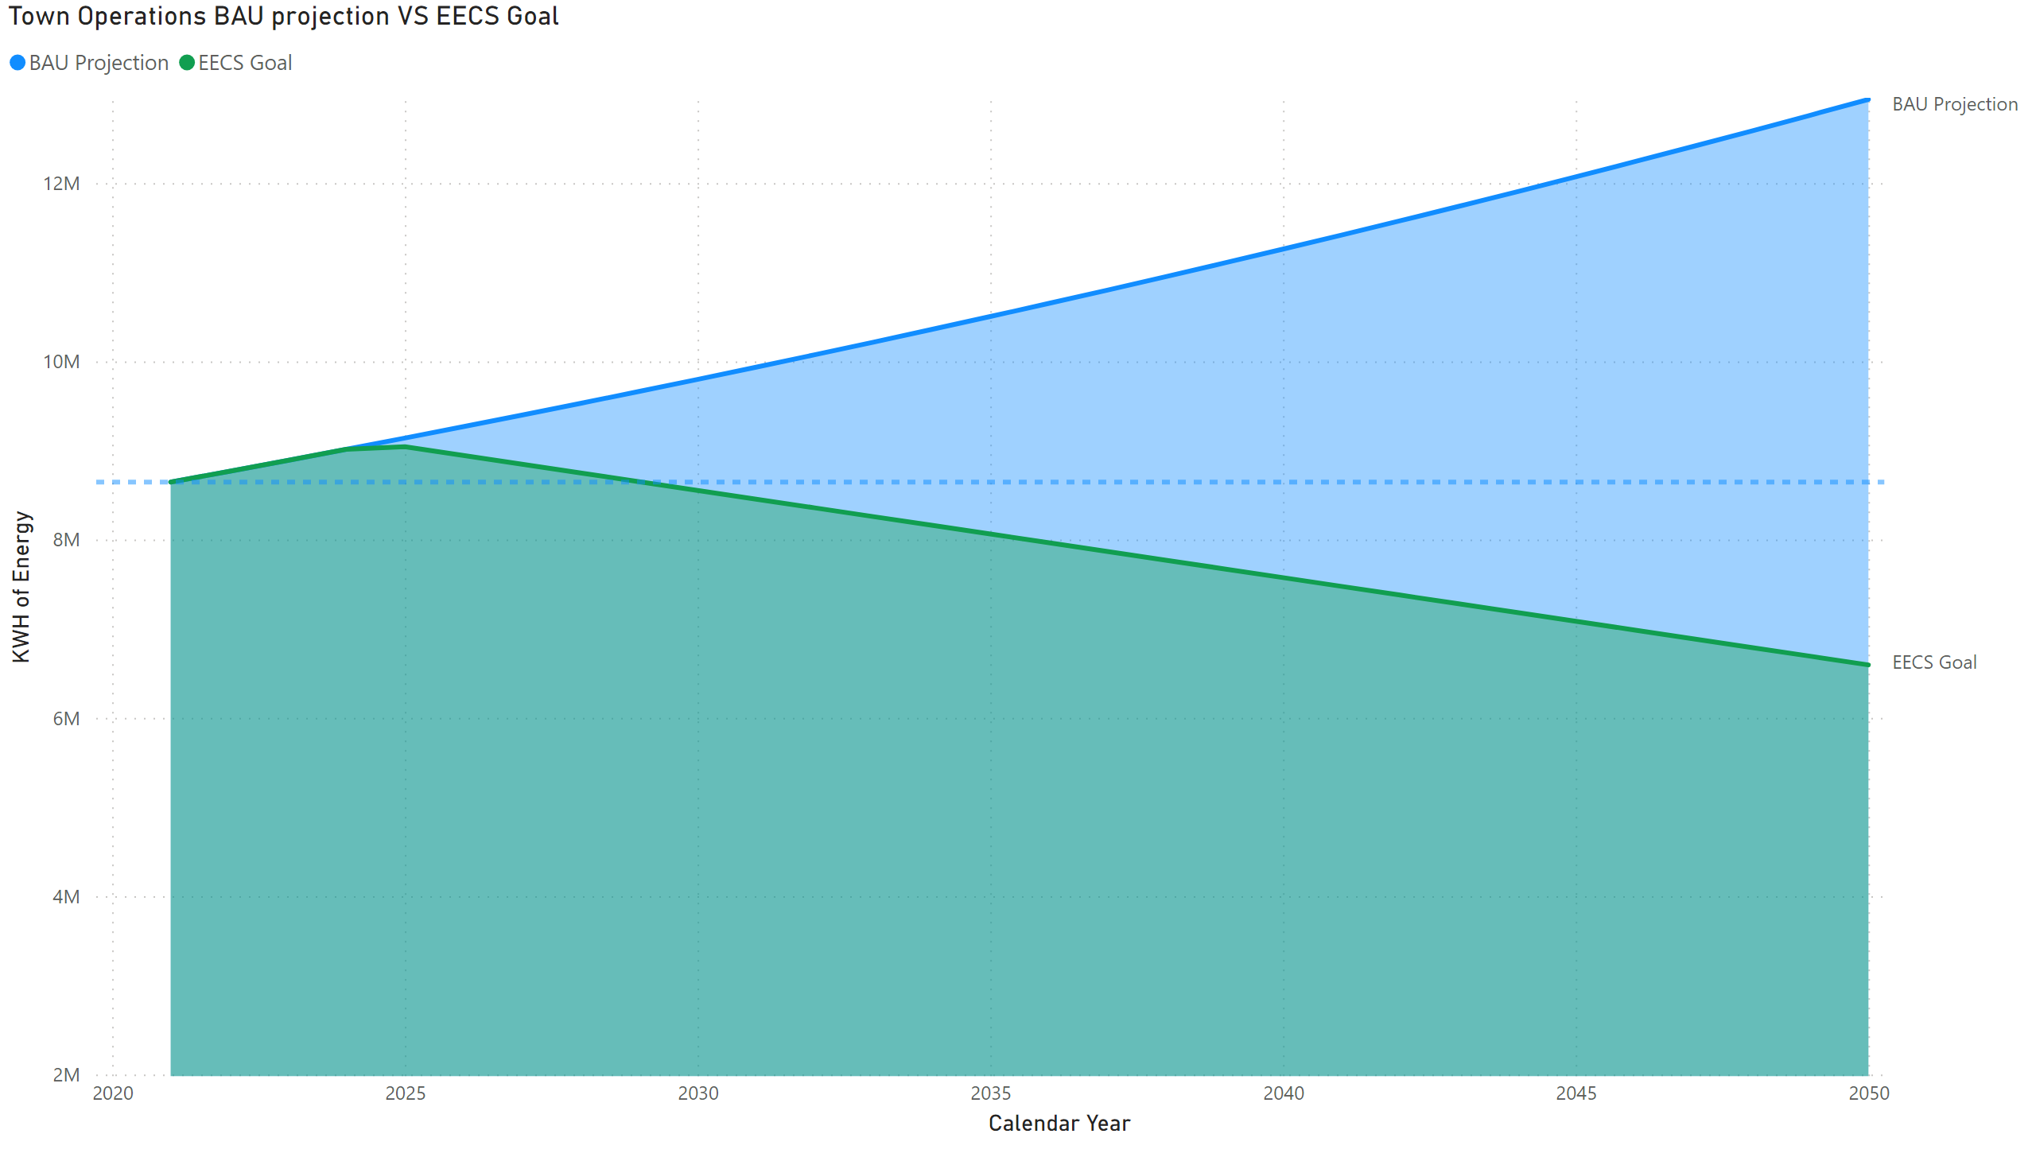](https://app.powerbigov.us/groups/me/reports/90c95898-9b9d-458b-8a76-ec62abd69f0f/?pbi_source=PowerPoint)

Figure 1

Wastewater and Water Treatment Operations Goals

1. 10% reduction in purchased energy (electric and natural gas) for wastewater and water treatment operations from business-as-usual projections by 2050.
2. By FY2026, upgrade existing Supervisory Control and Data Acquisition (SCADA) systems with remote telemetry to efficiently operate wastewater and water treatment operations.
3. Prioritize energy-efficient products for Utilities equipment replacements and improve pump and motor efficiency by correcting pump sizing, upgrading to premium efficiency motors, or variable frequency drives (VFD).

## Exisiting Strategy Documents

*Does your local government have an existing plan or strategy document (e.g., climate action plan, energy conservation plan, comprehensive energy plan, etc.) to reduce energy use, increase energy efficiency, reduce emissions, or train workers for high-quality energy efficiency jobs?*

The Town of Leesburg Environmental Advisory Commission, a group of residents appointed by the elected officials, created an energy policy in 2021. The policy can be found on the Town’s website by clicking [here](https://www.leesburgva.gov/home/showdocument?id=40994&t=638429949133617526).

One of the key actions in the energy policy is to report on energy usage more diligently. In July of 2023, the Town of Leesburg signed an agreement with EnergyCAP to synthesize and track energy consumption in all Town-owned facilities from all three energy utility providers. Having this information readily reviewable will allow the newly appointed Sustainability Manager to make more informed decisions about measurable energy efficiency plans. This data will feed the continued development of the Energy Policy and outline specific actions to take.

Using the blueprints for energy audits and energy performance service contracts, the Town of Leesburg will be able to add SMART goals to our Energy Policy and adapt the policy into a more comprehensive energy management plan. The funds will not be used directly for the enhancement of the plan but rather will provide information to staff to successfully update the plan while simultaneously working on energy efficiency strategies.

## Department of Energy Blueprints for Effective EECBG fund spending

*Are you planning to use a blueprint (see Section 4.5 of the EECBG Program Formula Grant Application Instructions document for more details)?*

The blueprints provided by the DOE for using EECBG funds provide a framework for effective actions. The Town Plans to use several of the blueprints. As the Town’s program continues to development, the sustainability team anticipates using one of three blueprints for our allocation of EECBG funds and then use additional funding to pursue the other blueprints. The three blueprints most likely to be used are: Energy efficiency: building audits and retrofits including grid interactivity and electrification, Energy savings performance contracts and electrification of municipal building, and Electric vehicle procurement.

Conducting audits of our buildings will be vital to identify the most cost-effective energy deficiencies and create long term plans for upgrades that will allow us to achieve our energy reduction and energy generation goals. The Town has been very interested in exploring energy savings performance contracts in the past, but at the time of this application are still working on procurement processes that would make it effective in the Town. If those items can’t be completed in a timely manner for the purposes of the EECBG funding allocation the Town will accelerate the plans to continue electrifying non-emergency response equipment.

## Coordination with state and other eligible local governments

*Local governments must coordinate and share information with the State in which the eligible local government is located regarding activities carried out using the grant to maximize the energy efficiency and conservation benefits under the EECBG Program. Have you coordinated and shared your planned activities with your State?*

The Town of Leesburg has communicated with Virginia Energy. Our Contact at Virgina Energy has made note of our project and provided us with additional contacts that might be able to provide additional support or guidance.

*Local governments must take into account any plans for the use of funds by adjacent eligible local governments that receive grants under the EECBG Program. Have you taken into account how adjacent eligible units of local governments plan to use their funds?*

The closet municipality receiving EECBG funds is Loudoun County. Staff have developed a strong relationship with leadership at Loudoun County. Loudoun County has a significantly higher formula fund and has not formally established their plans for using the funds at our last communication in early January 2024. Town staff have contacted County staff and have created a communication channel to stay connected on program progress.

1. The 2023 Sustainability report can be found the Town of Leesburg’s website by clicking [here](https://www.leesburgva.gov/home/showdocument?id=40990&t=638429877397974909).
2. 2 A reduction in purchased energy is achieved through energy conservation and municipally generated (solar, biogas etc.) energy. 
3. A base-case scenario that forecasts what would happen if the current business practices were to continue their current trajectories based on population growth. This data point was defined by using elements of a standard methodology for community scale inventories that were deemed applicable.
4. Emergency response vehicles are defined as those needed to function for continuous 24 hour periods in prevention or response to emergency situations. This includes, but is not limited to, police vehicles, on-call maintenance and heavy duty vehicles and equipment used in weather and other related safety management events.